**CA-1 727721euit172**

1->adding,removing,updating from cart,validating signin page navigation

Tc_001

Code:

Package com.taurus.ca1.ques1;

Import org.openqa.selenium.by;

Import org.openqa.selenium.webdriver;

Import org.openqa.selenium.webelement;

Import org.openqa.selenium.chrome.chromedriver;

Import org.openqa.selenium.chrome.chromeoptions;

Import io.github.bonigarcia.wdm.webdrivermanager;

Public class tc_001 {

public static void main(string[] args) throws interruptedexception {

chromeoptions co=new chromeoptions();

co.addarguments("--remote-allow-origins=*");

webdrivermanager.*chromedriver*().setup();

webdriver driver=new chromedriver();

driver.get("https://www.amazon.in/");

thread.*sleep*(2000);

driver.findelement(by.*xpath*("//*[@id=\"twotabsearchtextbox\"]")).click();

driver.findelement(by.*xpath*("//*[@id=\"twotabsearchtextbox\"]")).sendkeys("nike blazer shoes");

driver.findelement(by.*xpath*("//*[@id=\"nav-search-submit-button\"]")).click();

thread.*sleep*(2000);

driver.navigate().to("https://www.amazon.in/nike-men-blazer-vntg-bq6806/dp/b08q8rrr6b/ref=sr_1_1?crid=1x76vxihrgpch&keywords=nike+blazer+shoes&qid=1681289171&sprefix=nike+blazer+shoes%2caps%2c1217&sr=8-1") ;

driver.findelement(by.*xpath*("//*[@id=\"add-to-cart-button\"]")).click();

webelement cart=driver.findelement(by.*xpath*("//*[@id=\"nav-cart-count\"]"));

if(cart.gettext().equals("1")) {

system.***out***.print("added to cart is working successfully");

}else {

system.***out***.print("added to cart is not working successfully");

}

}

}

Output:

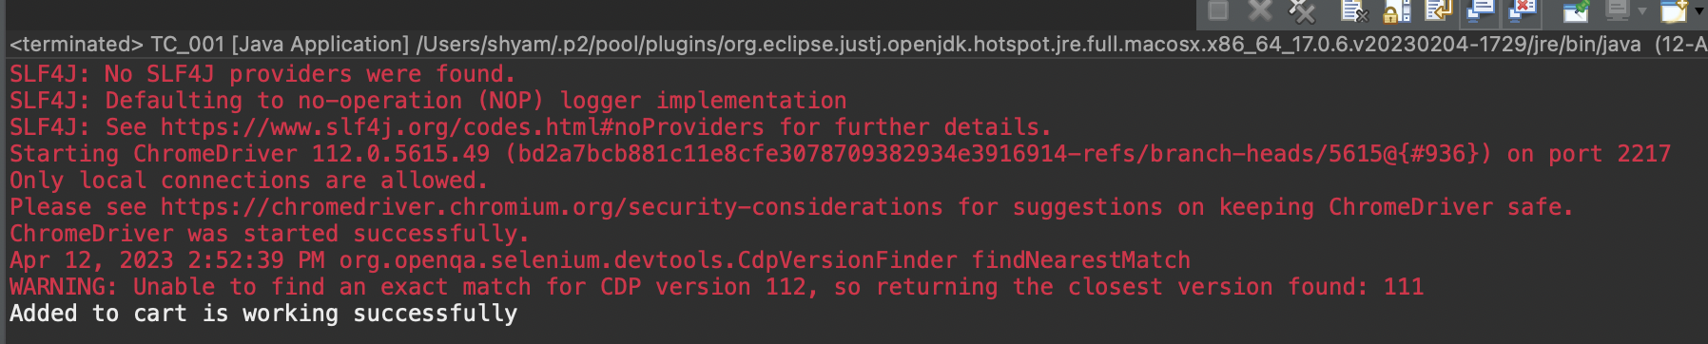

Tc_002

Code:

Package com.taurus.ca1.ques1;

Import org.openqa.selenium.by;

Import org.openqa.selenium.webdriver;

Import org.openqa.selenium.webelement;

Import org.openqa.selenium.chrome.chromedriver;

Import org.openqa.selenium.chrome.chromeoptions;

Import io.github.bonigarcia.wdm.webdrivermanager;

Public class tc_002 {

public static void main(string[] args) throws interruptedexception {

chromeoptions co=new chromeoptions();

co.addarguments("--remote-allow-origins=*");

webdrivermanager.*chromedriver*().setup();

webdriver driver=new chromedriver();

driver.get("https://www.amazon.in/");

thread.*sleep*(2000);

driver.findelement(by.*xpath*("//*[@id=\"twotabsearchtextbox\"]")).click();

driver.findelement(by.*xpath*("//*[@id=\"twotabsearchtextbox\"]")).sendkeys("nike blazer shoes");

driver.findelement(by.*xpath*("//*[@id=\"nav-search-submit-button\"]")).click();

thread.*sleep*(2000);

driver.navigate().to("https://www.amazon.in/nike-men-blazer-vntg-bq6806/dp/b08q8rrr6b/ref=sr_1_1?crid=1x76vxihrgpch&keywords=nike+blazer+shoes&qid=1681289171&sprefix=nike+blazer+shoes%2caps%2c1217&sr=8-1") ;

driver.findelement(by.*xpath*("//*[@id=\"add-to-cart-button\"]")).click();

driver.navigate().to("https://www.amazon.in/gp/cart/view.html?ref_=nav_cart");

thread.*sleep*(2000);

webelement cart=driver.findelement(by.*xpath*("//*[@id=\"nav-cart-count\"]"));

if(cart.gettext().equals("0")) {

system.***out***.print("removing from cart is working successfully");

}else {

system.***out***.print("removing from cart is not working successfully");

}

}

}

Output:

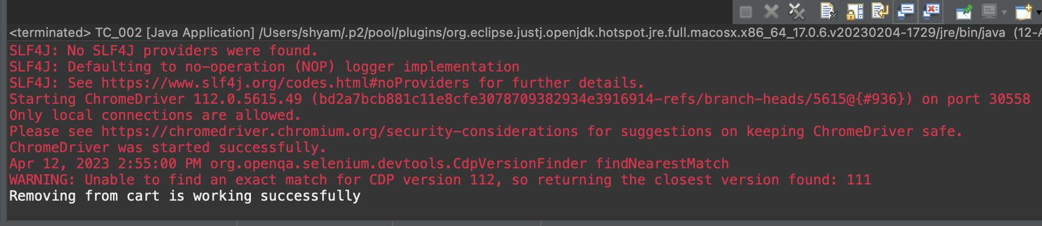

Tc_003

Code:

Package com.taurus.ca1.ques1;

Import org.openqa.selenium.by;

Import org.openqa.selenium.webdriver;

Import org.openqa.selenium.webelement;

Import org.openqa.selenium.chrome.chromedriver;

Import org.openqa.selenium.chrome.chromeoptions;

Import io.github.bonigarcia.wdm.webdrivermanager;

Public class tc_003 {

public static void main(string[] args) throws interruptedexception {

chromeoptions co=new chromeoptions();

co.addarguments("--remote-allow-origins=*");

webdrivermanager.*chromedriver*().setup();

webdriver driver=new chromedriver();

driver.get("https://www.amazon.in/");

thread.*sleep*(2000);

driver.findelement(by.*xpath*("//*[@id=\"twotabsearchtextbox\"]")).click();

driver.findelement(by.*xpath*("//*[@id=\"twotabsearchtextbox\"]")).sendkeys("nike blazer shoes");

driver.findelement(by.*xpath*("//*[@id=\"nav-search-submit-button\"]")).click();

thread.*sleep*(2000);

driver.navigate().to("https://www.amazon.in/nike-men-blazer-vntg-bq6806/dp/b08q8rrr6b/ref=sr_1_1?crid=1x76vxihrgpch&keywords=nike+blazer+shoes&qid=1681289171&sprefix=nike+blazer+shoes%2caps%2c1217&sr=8-1") ;

driver.findelement(by.*xpath*("//*[@id=\"add-to-cart-button\"]")).click();

driver.navigate().to("https://www.amazon.in/gp/cart/view.html?ref_=nav_cart");

driver.findelement(by.*xpath*("//*[@id=\"a-autoid-0\"]")).click();

driver.findelement(by.*xpath*("//*[@id=\"quantity_2\"]")).click();

thread.*sleep*(2000);

webelement cart=driver.findelement(by.*xpath*("//*[@id=\"nav-cart-count\"]"));

if(cart.gettext().equals("2")) {

system.***out***.print("updating cart is working successfully");

}else {

system.***out***.print("updating cart is not working successfully");

}

}

}

Output:

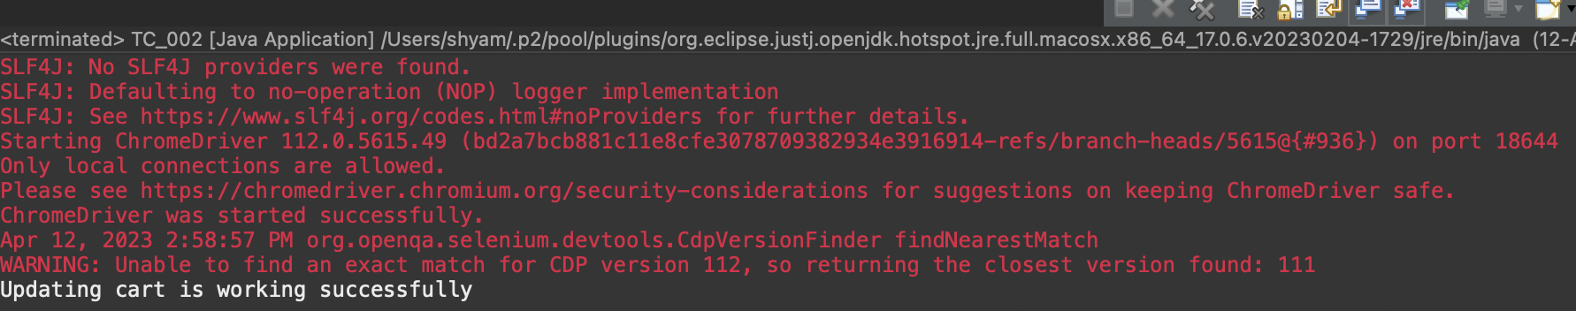

Tc_004

Code:

Package com.taurus.ca1.ques1;

Import org.openqa.selenium.by;

Import org.openqa.selenium.webdriver;

Import org.openqa.selenium.webelement;

Import org.openqa.selenium.chrome.chromedriver;

Import org.openqa.selenium.chrome.chromeoptions;

Import io.github.bonigarcia.wdm.webdrivermanager;

Public class tc_004 {

public static void main(string[] args) throws interruptedexception {

chromeoptions co=new chromeoptions();

co.addarguments("--remote-allow-origins=*");

webdrivermanager.*chromedriver*().setup();

webdriver driver=new chromedriver();

driver.get("https://www.amazon.in/");

thread.*sleep*(2000);

driver.findelement(by.*xpath*("//*[@id=\"twotabsearchtextbox\"]")).click();

driver.findelement(by.*xpath*("//*[@id=\"twotabsearchtextbox\"]")).sendkeys("nike blazer shoes");

driver.findelement(by.*xpath*("//*[@id=\"nav-search-submit-button\"]")).click();

thread.*sleep*(2000);

driver.navigate().to("https://www.amazon.in/nike-men-blazer-vntg-bq6806/dp/b08q8rrr6b/ref=sr_1_1?crid=1x76vxihrgpch&keywords=nike+blazer+shoes&qid=1681289171&sprefix=nike+blazer+shoes%2caps%2c1217&sr=8-1") ;

driver.findelement(by.*xpath*("//*[@id=\"add-to-cart-button\"]")).click();

driver.findelement(by.*xpath*("//*[@id=\"sc-buy-box-ptc-button\"]/span/input")).click();

webelement ele=driver.findelement(by.*xpath*("//*[@id=\"authportal-main-section\"]/div[2]/div/div[1]/form/div/div/div/h1"));

string actual=ele.gettext();

system.***out***.println(actual);

string expected="sign in";

if(actual.equals(expected)) {

system.***out***.print("navigated to sigin page");

}

}

}

Output:

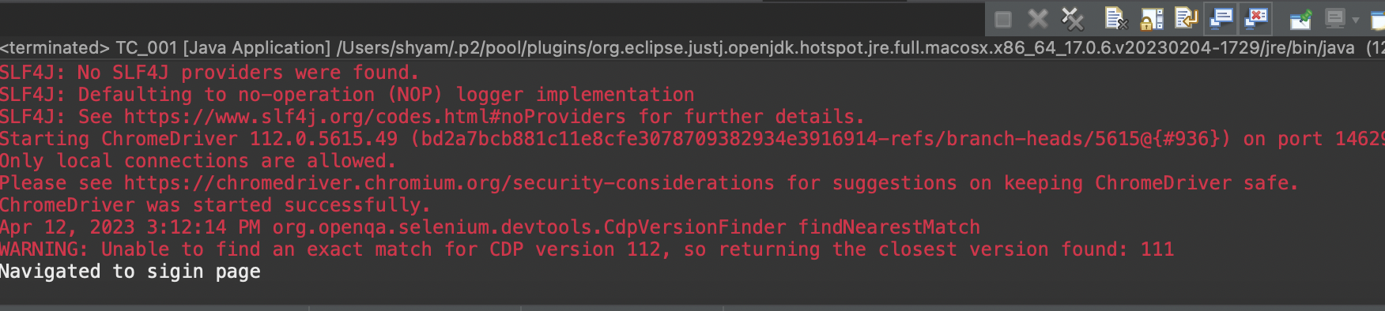

2→

Code:

Package com.taurus.ca1;

Import java.util.list;

Import org.openqa.selenium.by;

Import org.openqa.selenium.keys;

Import org.openqa.selenium.webdriver;

Import org.openqa.selenium.webelement;

Import org.openqa.selenium.chrome.chromedriver;

Import org.openqa.selenium.chrome.chromeoptions;

Import io.github.bonigarcia.wdm.webdrivermanager;

Public class ques2 {

public static void main( string[] args ){

chromeoptions co=new chromeoptions();

co.addarguments("--remote-allow-origins=*");

webdrivermanager.*chromedriver*().setup();//setting up chrome driver

webdriver driver=new chromedriver();

driver.get("https://www.amazon.in");

driver.findelement(by.*xpath*("//*[@id=\"twotabsearchtextbox\"]")).sendkeys(“shoes");

driver.findelement(by.*xpath*("//*[@id=\"twotabsearchtextbox\"]")).sendkeys(*keys*.***enter***);

string a=driver.gettitle();

if(a.equals("amazon.in : mobiles")) {

system.***out***.println("title is matched\n");

}

else {

system.***out***.println("title is mismatched");

}

list<webelement> li=driver.findelements(by.*classname*("s-line-clamp-2"));

for(int i=0;i<5;i++) {

system.***out***.println(li.get(i).gettext());

}

driver.findelement(by.*xpath*("//*[@id=\"p_36/1318505031\"]/span/a/span")).click();

webelement b=driver.findelement(by.*xpath*("//*[@id=\"search\"]/div[1]/div[1]/div/span[1]/div[1]/div[2]/div/div/div/div/div/div/div/div[2]/div/div/div[3]/div[1]/div/div[1]/div[2]/a/span[1]/span[2]/span[2]"));

system.***out***.print("price 2,000-10,000 :"+b.gettext());

driver.findelement(by.*xpath*("//*[@id=\"p_89/samsung\"]/span/a/div/label/i")).click();

webelement c=driver.findelement(by.*xpath*("//*[@id=\"search\"]/div[1]/div[1]/div/span[1]/div[1]/div[2]/div/div/div/div/div/div[2]/div/div/div[1]/h2/a/span"));

system.***out***.print("price 2,000-10,000 & mobile: "+ c.gettext());

}

}

Output: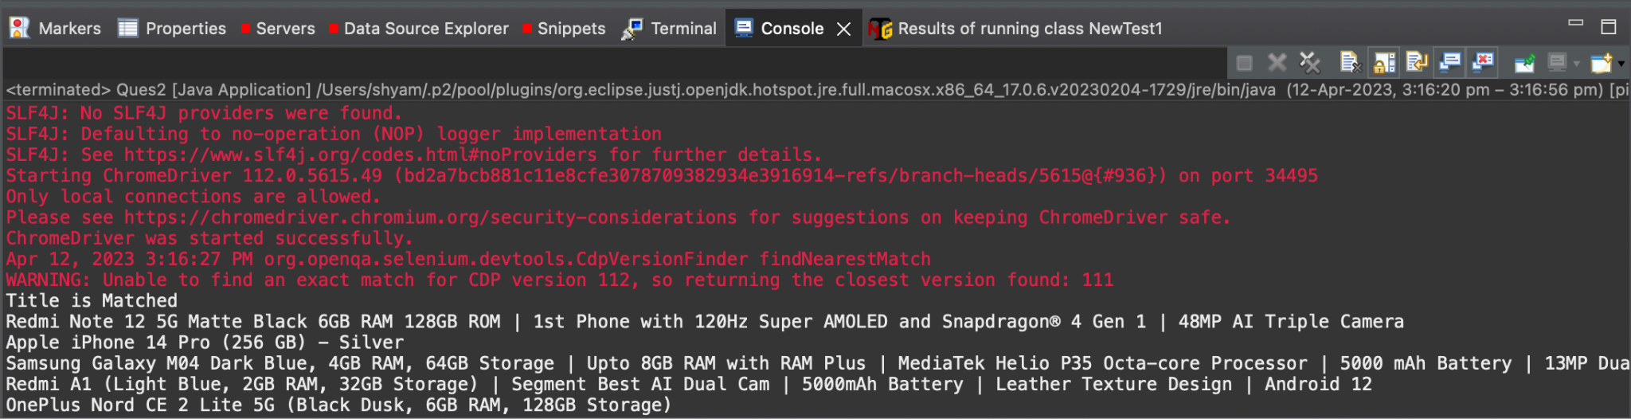

3→

Code:

package com.Taurus.Ca1;

import org.openqa.selenium.By;

import org.openqa.selenium.WebDriver;

import org.openqa.selenium.WebElement;

import org.openqa.selenium.chrome.ChromeDriver;

import org.openqa.selenium.chrome.ChromeOptions;

import io.github.bonigarcia.wdm.WebDriverManager;

public class Ques3 {

public static void main(String[] args) throws InterruptedException {

ChromeOptions co=new ChromeOptions();

co.addArguments("--remote-allow-origins=*");

WebDriverManager.*chromedriver*().setup();

WebDriver driver=new ChromeDriver();

driver.get("<https://www.amazon.in/ap/signin?openid.pape.max_auth_age=0&openid.return_to=https%3A%2F%2Fwww.amazon.in%2F%3Fref_%3Dnav_ya_signin&openid.identity=http%3A%2F%2Fspecs.openid.net%2Fauth%2F2.0%2Fidentifier_select&openid.assoc_handle=inflex&openid.mode=checkid_setup&openid.claimed_id=http%3A%2F%2Fspecs.openid.net%2Fauth%2F2.0%2Fidentifier_select&openid.ns=http%3A%2F%2Fspecs.openid.net%2Fauth%2F2.0&>");

//sigin

driver.findElement(By.*xpath*("//*[@id=\"ap_email\"]")).click();

driver.findElement(By.*xpath*("//*[@id=\"ap_email\"]")).sendKeys("6383715835");

driver.findElement(By.*xpath*("//*[@id=\"continue\"]")).click();

driver.findElement(By.*xpath*("//*[@id=\"ap_password\"]")).click();

driver.findElement(By.*xpath*("//*[@id=\"ap_password\"]")).sendKeys("uma_kiru_006");

driver.findElement(By.*xpath*("//*[@id=\"signInSubmit\"]")).click();

Thread.*sleep*(3000);

driver.findElement(By.*xpath*("//*[@id=\"nav-link-accountList\"]")).click();

WebElement acc=driver.findElement(By.*xpath*("//*[@id=\"a-page\"]/div[2]/div/div[1]/h1"));

String actual=acc.getText();

String expected="Your Account";

if(actual.equals(expected)) {

System.***out***.println("Your Account page is displayed");

}

driver.findElement(By.*xpath*("//*[@id=\"a-page\"]/div[2]/div/div[2]/div[1]/a/div")).click();

WebElement ord=driver.findElement(By.*xpath*("//*[@id=\"a-page\"]/section/div[1]/div[2]/div[1]/h1"));

String act=ord.getText();

String exp="Your Orders";

if(act.equals(exp)) {

System.***out***.println("Your Order page is displayed");

}

// driver.findElement(By.xpath("//*[@id=\"a-page\"]/div[2]/div/div[2]/div[1]/a/div")).click();

// WebElement trac=driver.findElement(By.xpath("//*[@id=\"a-page\"]/section/div[1]/div[2]/div[1]/h1"));

String act1=ord.getText();

String exp1="Your orders";

if(act.equals(exp)) {

System.***out***.println("User is able to track package");

}

// driver.findElement(By.xpath("//*[@id=\"pop\"]/div/div[2]/div/div[1]/div/div[3]/div/div/div/div/div[2]/div/div/a")).click();

System.***out***.println("User is able to view their products");

}

}

